# Department of Computing

**CS-344: Web Engineering**

**Class:** BESE-9AB

# Lab 01: Introduction to DreamWeaver and HTML

**Date: October 15, 2020**

**Time 10:00am to 1pm & 2pm to 5pm**

# Instructor: Dr. Qaiser Riaz

# 

# Ahmed Hassan Ismail – BESE-9B - 237897

# Lab 01: Introduction to DreamWeaver and HTML

### Introduction:

Students will familiarize themselves with DreamWeaver and will practically learn basic concepts of HTML.

### Lab Objectives:

This objective of this lab is to help students in setting up their systems for web engineering and familiarizing themselves with the development environments for HTML and basic concepts of HTML.

### Helping Material:

<https://www.w3schools.com/html/default.asp>

### Lab Tasks

### Task 1

With the help of Lab Engineer, install on your laptops important tools for Web Engineering such as Apache2 Web Server, PHP5, MySQL, DreamWeaver, and Eclipse for PHP etc.

### Task 2

Visit W3Schools website mentioned above. Read following three sections on the website:

* HTML Introduction
* HTML Editors
* HTML Basic

Your task is to first familiarize yourself with the following HTML tags: **DOCTYPE**, HTML, BODY, Headings (H1, H2, H3, H4, H5, H6), HTML Paragraphs (<P>), and HTML Links (<a>). Once you have learned these tags, you have to create a personal HTML page similar to the following image:

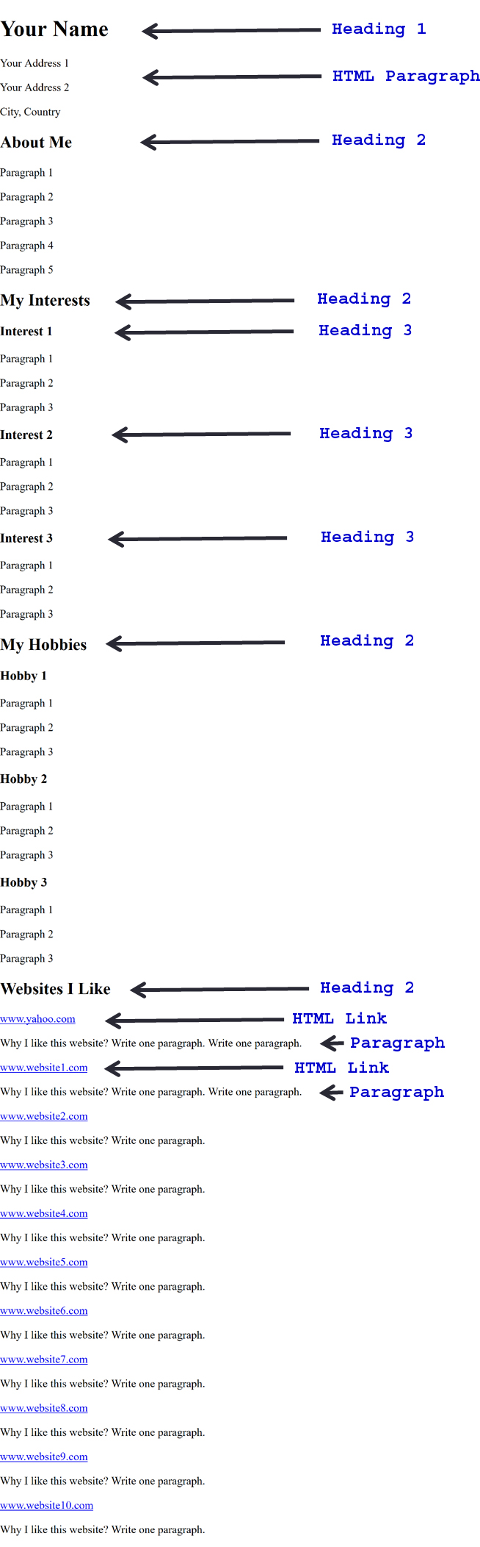

**Answer:**

|  |
| --- |
| Solution |
| Screenshot of task 2        HTML Code  <!doctype html>  <html>  <body>      <h1>Ahmed Hassan Ismail</h1>      <p>A-16/13 Afandi Colony, Sadiqabad Road</p>      <p>Rawalpindi, Pakistan</p>      <h2>About Me</h2>      <p>I am an undergraduate student currently</p>      <p>pursuing the Bachelors in Software</p>      <p>Engineering programme at NUST</p>      <p>sector H-12 Islamabad</p>      <h2>My Interests</h2>      <h3>-Web Development</h3>      <p>--node.js react.js etc</p>      <h3>-Mobile Application Development</h3>      <p>--Android application development using Flutter</p>      <h3>-Machine Learning and Artificial Intelligence</h3>      <p>--Deep learning using Numpy and Pandas</p>      <h2>My Hobbies</h2>      <h3>-Book reading</h3>      <p>--Because books are awesome</p>      <h3>-Self Learning</h3>      <p>--A hobby that isn't much common these days</p>      <h3>-Watching movies</h3>      <p>--I like Chrostopher Nolan's classics</p>      <h2>Websites I like</h2>      <a href="www.facebook.com">www.facebook.com</a>      <p>-Because I can socialize with my friends and acquaintances</p>      <a href="www.youtube.com">www.youtube.com</a>      <p>-To get rid of boredom.</p>      <a href="www.udemy.com">www.udemy.com</a>      <p>-To learn and study various topics</p>      <a href="www.coursera.com">www.coursera.com</a>      <p>-To learn and gain skills on select topics</p>      <a href="www.linkedin.com">www.linkedin.com</a>      <p>-To share my portfolio to the world and discover oppurtunities related to my field</p>  </body>  </html> |

### Deliverables

Compile a single word document by filling in the solution part and submit this Word file on LMS. You must include your name, ID, and class on first page. The lab grading policy is as follows: The lab is graded between 0 to 10 marks. For some of the labs, students must present their solutions in a viva session. In case of any problems with submissions on LMS, you should contact your lab engineer Mr. Aftab Hussain by email at [aftab.hussain1@seecs.edu.pk](mailto:aftab.hussain1@seecs.edu.pk).